PTRF-433: 433 MHz Transceiver Module
(Similar Modules Available in 915 MHz and 868 MHz)

Introduction
The PTRF-433 operates in the 433 to 435 MHz band. Its design is based on the XEMICS XE1202 single chip transceiver and is capable of use in data transmission for narrowband FSK applications.

In addition to the XE1202, the module incorporates a SAW filter that is used for both transmitting and receiving, a high accuracy quartz crystal, a low-loss transmit/ receive switch and all of the carefully selected passive components necessary to get the highest performance from the XE1202.

The design is pre-certified to ETSI EN 300 220 and ETSI EN 301 489, and FCC part 15.231 regulations, which means that the testing that will need to be done on products incorporating this module will go much more smoothly than if you started from scratch with a design using the XE1202 integrated circuit.
The PTRF-433 works in systems with an external processor. Assistance in integration, customization, firmware development or modification, and certification is available from Pegasus Technologies.

Features
- FCC and CE Pre-Certified Radio Design
- Reverse-Polarity SMA Connector
- Digital Radio uP Interface
- Low Cost Design
- Production Ready
- Bit Synchronizer
- Programmable Power Output
- Alignment Free
- Optimized RF performance
- Few External Components
- Low Voltage / Low Current
- Reduces Design Time
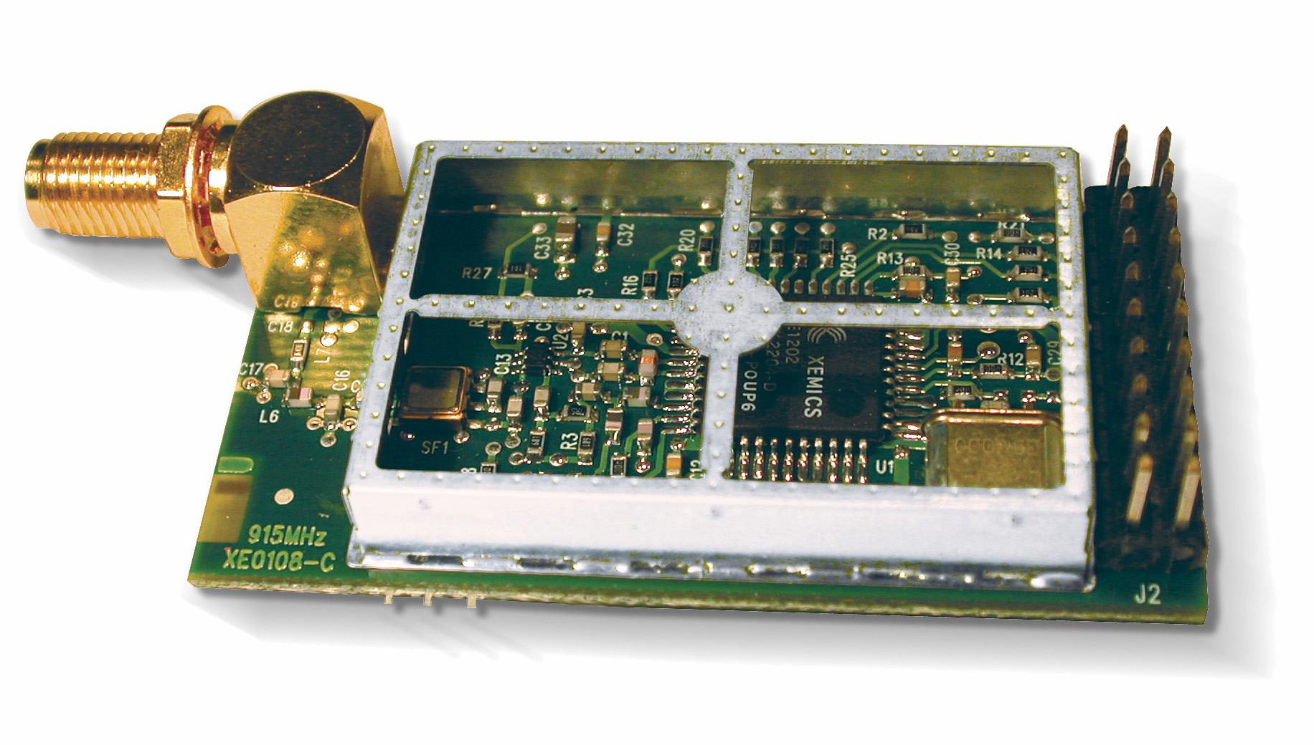

Specifications
Frequency: 433 to 435 MHz
Modulation: FSK
Programmable Data Rates: 4.8 kbps to 76.8 kbps
Output Power: 8 dBm
Receiver Sensitivity: -110 dBm, Typical (5kHz deviation, 4.8 kbps, 10⁻³ BER)
TX Current: 48 mA @ 10 dBm
RX Current: 16 mA
Supply Voltage 2.7 to 3.6 V
Regulatory Compliance: EN 300 220 and EN 301 489, and FCC part 15.231
Temperature Range: -40 to +85 C
Module Size: 52 mm x 29 mm

For a complete overview of the operation of this module, refer to the datasheet for the XE1202 transceiver integrated circuit (see http://sss-mag.com/pdf/xe1202_datasheet.pdf ).

For more information, contact:
sales@pegasustech.com
865-717-9339
www.pegasustech.com

Specifications subject to change without notice.

