PTRF-915: 915 MHz Transceiver Module
(Similar Modules Available in 868 MHz and 433 MHz)

Introduction
The PTRF-915 operates in the 902 to 928 MHz band. Its design is based on the XEMICS XE1202 single chip transceiver and is capable of use in data transmission for both narrowband FSK and FHSS applications.

In addition to the XE1202, the module incorporates a SAW filter that is used for both transmitting and receiving, a high accuracy quartz crystal, a low-loss transmit/ receive switch and all of the carefully selected passive components necessary to get the highest performance from the XE1202.

The design is pre-certified to FCC Part 15.247 and Part 15.249 regulations, which means that the testing that will need to be done on products incorporating this module will go much more smoothly than if you started from scratch with a design using the XE1202 integrated circuit.
The PTRF-915 works in systems with an external processor. A firmware license is available for FHSS operation. Assistance in integration, customization, firmware development or modification, and certification is available from Pegasus Technologies.

Features
- FCC Pre-Certified Radio Design
- Reverse-Polarity SMA Connector
- Digital Radio uP Interface
- Low Cost Design
- Production Ready
- Bit Synchronizer
- Programmable Power Output
- Alignment Free
- FHSS Algorithm Available For License
- Optimized RF performance
- Few External Components
- Low Voltage / Low Current
- Reduces Design Time
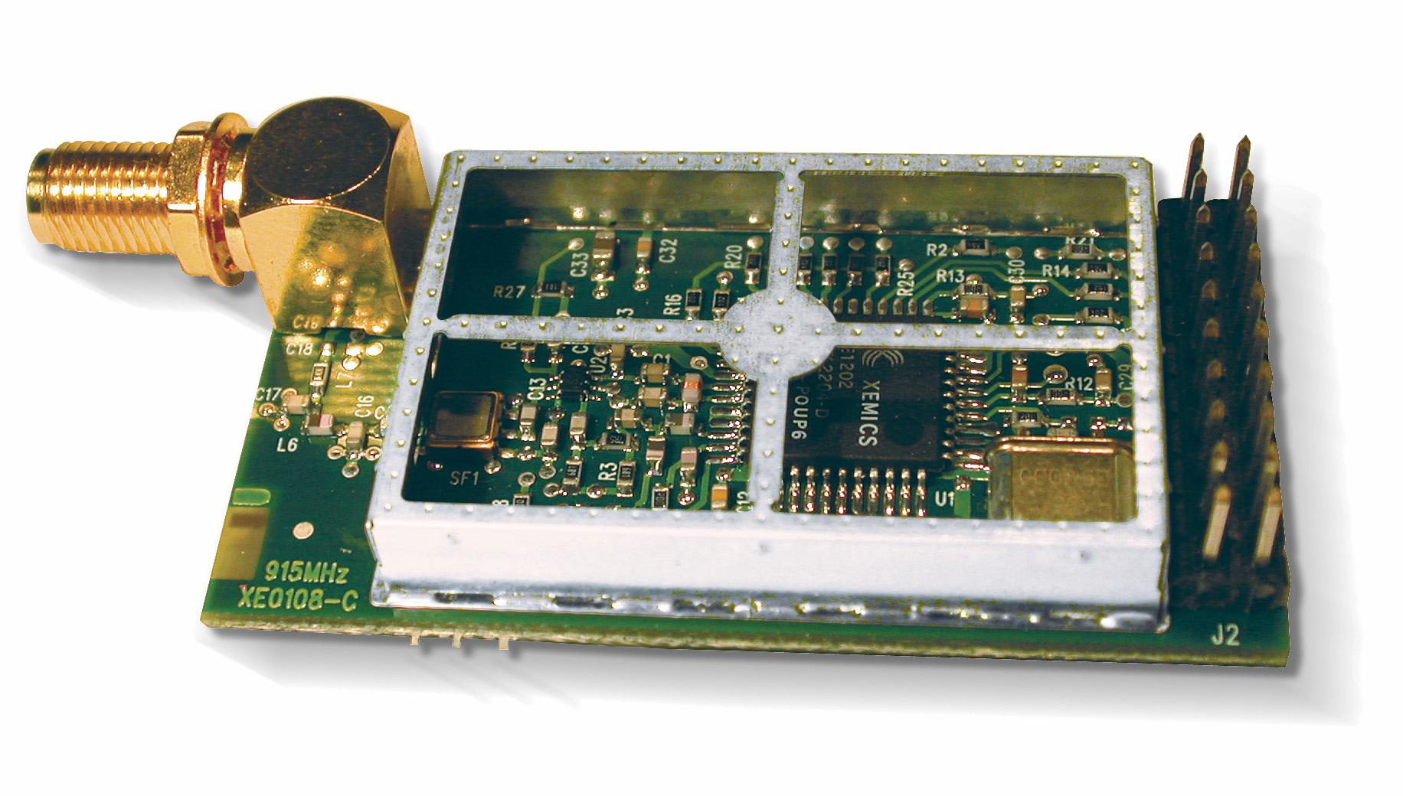

Specifications
Frequency: 902 to 928 MHz
Modulation: FSK (supports FHSS)
Programmable Data Rates: 4.8 kbps to 76.8 kbps
Output Power: 11 dBm
Receiver Sensitivity: -111 dBm, Typical (5kHz deviation, 4.8 kbps, 10⁻³ BER)
TX Current: 48 mA @ 11 dBm
RX Current: 16 mA
Supply Voltage 2.7 to 3.6 V
FCC Compliance: Per Part 15.247 & Part 15.249 (using Nearson antenna part # C321 AH-925)
Temperature Range: -40 to +85 C
Module Board Size: 1.102” x 2.216” x 0.315” (2.8 cm x 5.4 cm x 0.8 cm)
Weight: 0.6 oz. (18.662 g)

For a complete overview of the operation of this module, refer to the datasheet for the XE1202 transceiver integrated circuit (see http://sss-mag.com/pdf/xe1202_datasheet.pdf ).

For more information, contact:
sales@pegasustech.com
865-717-9339
www.pegasustech.com

Specifications subject to change without notice.

