
Pegasus Technologies, Inc.

www.PegasusTech.com (865) 717-9339

PTSS2003DK Developer’s Kit

This kit will greatly simplify the job of incorporating the PTSS2003 RF transceiver module into your designs. With our easy setup and configuration, in a matter of minutes you can put the 250 mW transmit power of the FCC-certified PTSS2003 Transceiver to work for you!
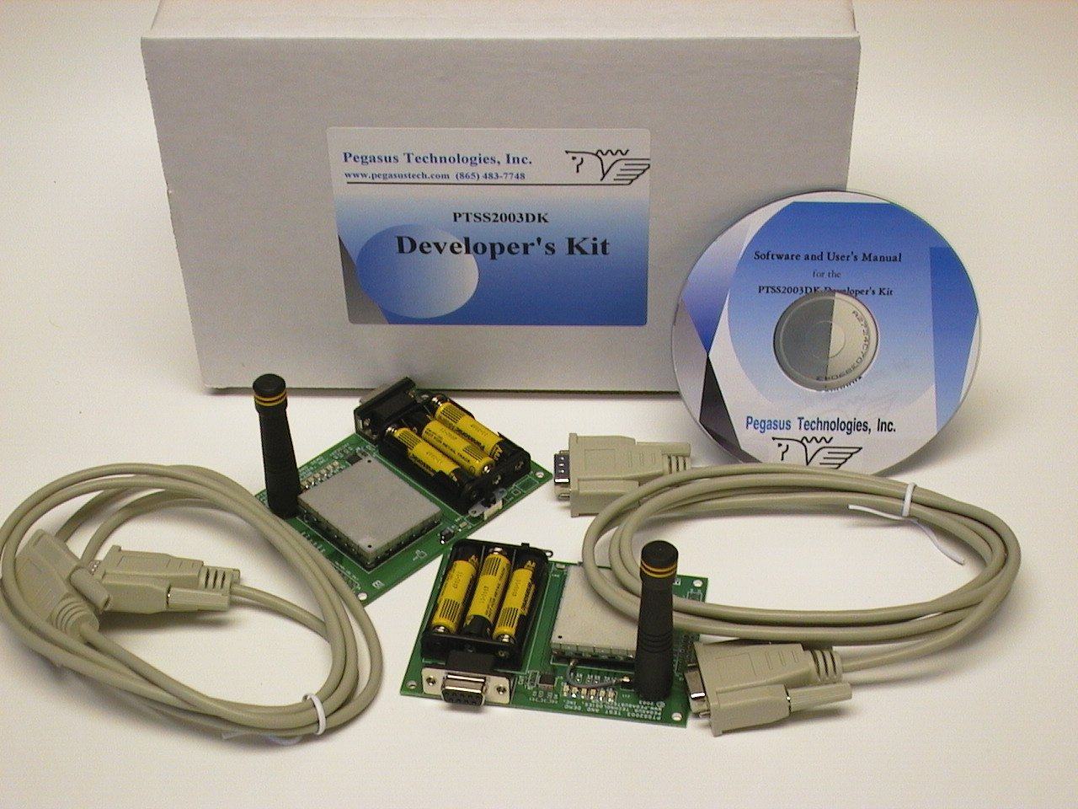
Kit contents:

2 PTSS2003 Transceiver Modules
2 PTSS2003TB1 Demo Boards
2 Rubber Flex Antennas
2 RS-232 Serial Cables
6 AAA Alkaline Cells
CD-ROM containing:
Configuration Software
User’s Manual

The self-contained demo boards permit you to plug in the PTSS2003 RF modules and see how they operate within minutes. Each board includes a built-in battery holder with 3 AAA alkaline cells and a switch, which permits range testing without the need to be tied to a power source. It also includes LED lights to provide visual evidence that signals have been received, and provides built-in serial logic level conversion to and from standard RS-232 interface cables. The modules are pre-configured in power-up test mode, one as a receiver and the other as a transmitter. These configurations and others can be easily changed using the provided software.

When ordering, ask for Part Number PTSS2003DK. Acceptable methods of payment include advance check, money order, or Net-30 terms (with prior approval).

Let us be your RF experts – for more information on our consulting services, visit www.pegasustech.com or call (865) 717-9339.

The PTSS2003 Developer’s Kit ...  - Supports the FCC-certified frequency hopping spread spectrum 915 MHz band PTSS2003 RF transceiver module  - Enclosed units include switched battery-powered operation and permit direct RS-232 interface | - Includes all components necessary to get the units up and running right away  - Easy setup and configuration  - Detailed documentation and full technical support speeds up the integration process

PTSS2003DK Specifications

System Requirements:  2 IBM compatible PCs running Windows 98 or higher, each with an available serial port and a CDRom drive. | Software:  The CD contains configuration and test modes which allows range test measurements, power management control, data encryption options, hop table selection, and more.

Kit Component | Application
2 PTSS2003 Transceiver modules | - Range testing for your application  - Mechanical fit testing  - Data transmission
- 2 PTSS2003TB1 Demo Boards | - Serial logic conversion to/from RS-232  - Connection with PTSS2003 module  - LED indicator lights for reception testing  - Switched battery power for unplugged operation and testing
- 2 Rubber Flex Antennas | Small, convenient and cost-efficient antennas plug directly into connector on demo board.
- 2 RS-232 Serial Cables | Connect the Demo Board to the PC’s serial port
- 6 AAA Alkaline Cells | Provide tether-free power for the Demo Board for easy range testing.
Configuration Software  (Contained on the CD Rom) | - Setup configuration for range testing, power testing, or normal operation  - Selection of hop table  - Console version and Windows version  - Reloading of firmware for updates and custom applications
Detailed Documentation (contained on the  CD Rom) | User’s Manual contains complete details of the communication protocol between the PTSS2003 and your system.
Engineering Support | Assistance in your integration effort is included as part of the development kit. Additional engineering support and transceiver hardware/firmware customization can be quoted by Pegasus Technologies.

