FOR IMMEDIATE RELEASE

“Versatile New FCC-Approved Transceiver Module Simplifies Wireless Design”

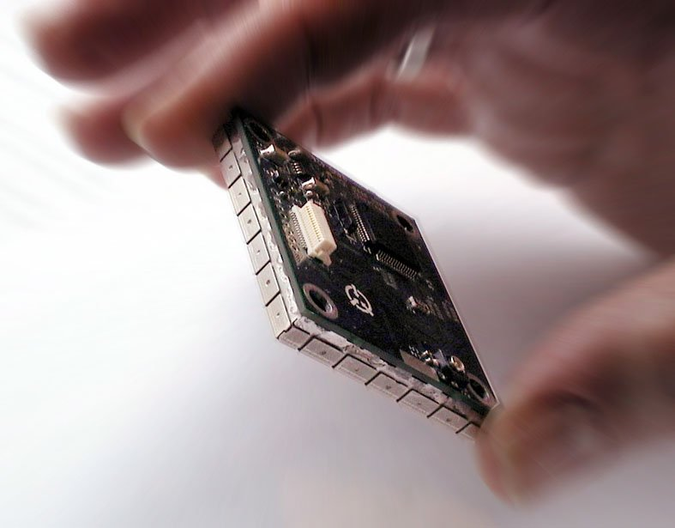

Neuchâtel, Switzerland, Mountain View, CA and Oak Ridge, TN, February 25th, 2003

Pegasus Technologies, Inc., announced the release today of the PTSS2003 915 MHz Band Transceiver. This revolutionary module features the versatile XEMICS ultra-low-power XE1202 transceiver chip. The PTSS2003 has been granted FCC modular approval for frequency-hopping spread spectrum data transmissions. This removes a major hurdle for systems integrators that hope to add wireless data or control to their products. No longer will they have to face the uncertainties of FCC transmitter testing since the modular approval allows the PTSS2003 to be integrated without additional testing.
The PTSS2003 can be easily integrated into existing systems as well as new designs. With its small size (1.7”x1.5”x.35”), low standby power consumption, 250 mW transmit power, high receiver sensitivity of –107dBm, and customizable microcontroller operation, this module will provide a simple wireless solution for a wide variety of applications.
A simple set of serial commands from a host processor controls the operation of the module and allows for efficient data communication. In situations where there is no host for the system, or for high volume applications, the embedded TI MSP430 microcontroller firmware can be easily customized by Pegasus Technologies to meet the needs of the application. Since the microcontroller includes an on-chip analog to digital converter, the module can be used as a stand-alone wireless data acquisition system. The module will be debuted at the Wireless Systems Design Conference in San Jose, February 24 – 26, 2003.
Other features include user-selectable hop table (65536 tables), use of a SAW filter for high interference rejection, CRC-16 Error Detection with user-selectable auto resend on error, a user-selectable data encryption capability, and a baud rates of 76.8 kbits/second. The modules can be used with a variety of antenna styles to suit different applications.
“There is simply no other module on the market that combines all these features and options in one package,” said Jim Pearce, President of Pegasus Technologies. “This module, which is already being tested in a variety of wireless applications including remote sensor monitoring, machine operations, and keyless entry, is the most versatile RF transceiver available.”
The PTSS2003 is competitively priced -- less than $100 in 1000 unit quantities -- and is available 3 weeks after receipt of order. A developers’ kit, consisting of 2 modules, interface boards, antennas, and cables is available for $689. Versions for the European and Asian markets are in development.

The XEMICS XE1202 can operate in the European (868MHz - 870MHz) and North American (902MHz - 928MHz) as well as Asian frequency bands and is backwards compatible to the XE1201A transceiver operating in the 433MHz band. The programmable on-chip filters allow for dynamic switching between narrow-band and wide-band operations, without any modifications to the external RF front-end design.

The XE1202 can transmit and receive data from as low as 4.8kbps right up to 76.8kbps, RF output power can be programmed up to +15dBm (31.5mW) and the current consumption while in reception mode is 12mA. The on-chip frequency synthesizer ensures that the chip can handle multi-channel as well as frequency hopping spread-spectrum communications. “XEMICS is proud to partner with such an outstanding RF design company as Pegasus Technologies, as this allows customers seeking powerful and quick solutions built around our XE1202 transceiver chip to move faster to production!”, said Tom Hoyt, VP Sales XEMICS USA.

About XEMICS
XEMICS is a privately owned fabless semiconductor company with headquarters in Switzerland and a worldwide sales and customer support network. XEMICS delivers a range of advanced short-range wireless connectivity solutions to a global customer base. XEMICS is a leading designer and provider of Wireless RF transceivers and Bluetooth™ applications, data acquisition, communication products, CODECs and GPS receivers. With a focus on high-quality low cost solutions XEMICS provides a combination of ultra-low power technology and innovative IC design.

For further information, please contact:

Isabelle Bellaton

Marketing Communications Manager
XEMICS Switzerland
Phone: +41 32 720 5562
Fax: +41 32 720 5770

E-Mail: pr@xemics.com
Website: www.xemics.com

About Pegasus Technologies
Pegasus Technologies is a leading provider of custom RF and advanced electronic designs since 1998. The company specializes in providing innovative engineering solutions for today's RF, wireless and Spread Spectrum needs, using state of the art technology and award-winning design and development expertise, concepts and techniques. Pegasus Technologies is the host of the most popular web site devoted to wireless technology, Spread Spectrum Scene Online (sss-mag.com).
Contact Pegasus Technologies today at (865) 717-9339 or via the web at http://sss-mag.com/ptss2003.html for PTSS2003 pricing and detailed specifications.
Jim Pearce, President
Phone: 1-865-717-9339
E-mail: jwp@pegasustech.com
Website: http://sss-mag.com/rfss/index.html or www.pegasustech.com/

